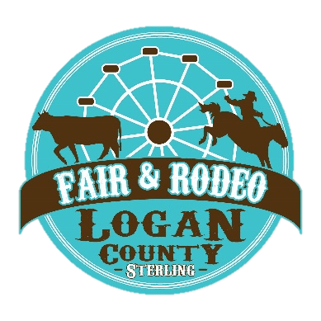
Fair Manager, Guy McEndaffer
mandmfarms@aol.com

Fair Administrative Assistant,
Danny Gutierrez-Dutton
gutierrezd@logancountyco.gov

315 Main Street | Sterling, CO 80751
970-522-0888 ext. 222

2024 Mutton Bustin’ Entry Form
Requirements:
- 5, 6, 7-year-old boys or girls (Must be at least 5 years of age and not have reached 8th birthday as of August 1, 2024)
- Participants must weigh 55 pounds or less.
- Must be a Logan County Resident
- Each rider will wear a helmet and flack jacket provided by Logan County Fair
- If your child was selected in 2023, they are not eligible for 2024.
Details:
- Entry deadline is Friday, July 12, 2024 at 5 p.m. at the Logan County Extension Office (508 S. 10th Avenue #1, Sterling, CO 80751)
- No Entry Fee – Prizes for each participant
- NO guarantee of participation. 10 entries will be randomly selected for each PRCA rodeo (Thursday, Aug. 1 at 7 p.m. and Friday, Aug. 2 at 7 p.m.) Preference will be given to first time riders.
- Random Selection will be held at the Logan County Fair Office (315 Main Street, Sterling, CO 80751) on Monday, July 15, 2024, at 9 a.m. with notification beginning Tuesday, July 16, 2024. ONLY THOSE SELECTED WILL BE NOTIFIED!

Return only this portion. Please print legible.
Child’s Name: ___________________________________________________________ Male: Female:
Date of Birth: (must be at least 5 years of age and not have reached 8th birthday as of Aug. 1, 2024): ________________________________________________
Weight of Child (Maximum weight is 55 lbs. for the rider): ____________________________
Parent(s) / Guardian(s) Name(s): ________________________________________________________________________________
Address: ______________________________________________________ Contact Number: _______________________________

We will only accept one entry per child.
The undersigned Parent(s) / Guardian(s) hereby voluntarily assume all risks arising out of and/or connected with the above named Child’s participation in the Logan County Fair Mutton Bustin’ event (the “Event”) and hereby releases and holds harmless the Logan County Fair Mutton Bustin’ Event and event sponsors, Logan County Fair Board of County Commissioners, Logan County Fairgrounds, and the employees, agents and officers thereof, from any and all liability and waves any and all claims and causes of action whatsoever for damages or costs that may arise from any injury sustained by the Child or property damage that results from the Child’s participation in the Event. The under-signed Parent(s)/ Guardian(s), by signing this agreement, acknowledges that the Child’s participation in the Event involves certain risks, and the undersigned hereby assumes the risks inherent in the activity with full knowledge of the risks involved.

Parent(s) / Guardian(s) Signature: ___________________________________________________ Date: _______________________

